Loading node and edge data from Snowflake...
Loaded 150023 nodes and 156032 edges

====================================================================================================
FAN-OUT DETECTION ANALYSIS
====================================================================================================

Fan-out = Number of outgoing edges from a node
High fan-out nodes may indicate:
• Money laundering hubs (distributing funds to many destinations)
• Compromised customer accounts (initiating many transactions)
• Bot/automated transaction sources
• High-volume transaction originators
• Phishing/scam accounts spreading to multiple victims

Calculating fan-out metrics for all nodes...
✅ Analysis complete!

====================================================================================================
OVERALL FAN-OUT STATISTICS
====================================================================================================

📊 Summary:
Total nodes: 150026
Nodes with outgoing edges: 93140 (62.1%)
Nodes with no outgoing edges: 56886
Average fan-out: 1.04
Maximum fan-out: 9

📈 FAN-OUT BY NODE TYPE:
Node Type Avg Fan-Out Max Fan-Out Total Nodes
------------------------------------------------------------
Account 1.00 8 50006
Customer 1.40 8 40005
Device 1.50 9 20005
Transaction 0.50 5 40007
(Unknown) 2.00 4 3

====================================================================================================
TOP NODES BY FAN-OUT (Potential High-Risk Distributors)
====================================================================================================

Rank Node ID Type Name Fan-Out Fan-In
------------------------------------------------------------------------------------------
1 DEV016563 Device Dell Laptop #16563 9 2
2 CUST005164 Customer William Brown 5164 8 1
3 CUST006640 Customer Robert Taylor 6640 8 1
4 CUST017865 Customer Daniel Thompson 17865 8 0
5 CUST018357 Customer Thomas Jackson 18357 8 0
6 ACCT005531 Account Business Account #5531 8 2
7 CUST023226 Customer Christina Lopez 23226 8 2
8 CUST031686 Customer Rachel Green 31686 8 0
9 CUST001980 Customer Patricia White 1980 7 0
10 CUST004568 Customer Daniel Thompson 4568 7 1
11 CUST005424 Customer David Williams 5424 7 0
12 CUST008733 Customer Nancy Martin 8733 7 3
13 CUST015130 Customer Jessica Davis 15130 7 2
14 CUST015145 Customer Jessica Davis 15145 7 2
15 CUST017221 Customer Robert Taylor 17221 7 1

====================================================================================================
DETAILED HIGH FAN-OUT ANALYSIS
====================================================================================================

Analyzing 14981 nodes with fan-out >= 3

────────────────────────────────────────────────────────────────────────────────────────────────────
🔍 High Fan-Out Node #1
────────────────────────────────────────────────────────────────────────────────────────────────────
Node ID: DEV016563
Type: Device
Name: Dell Laptop #16563
Fan-Out Count: 9
Fan-In Count: 2
Fan-Out/Fan-In Ratio: 4.5

Outgoing Edge Types:
• USED_BY: 9

Destination Node Types:
• Customer: 9

Outgoing Connections (showing first 8):
1. DEV016563 --[USED_BY]--> CUST030966 (Customer)
2. DEV016563 --[USED_BY]--> CUST031237 (Customer)
3. DEV016563 --[USED_BY]--> CUST020572 (Customer)
4. DEV016563 --[USED_BY]--> CUST021192 (Customer)
5. DEV016563 --[USED_BY]--> CUST038699 (Customer)
6. DEV016563 --[USED_BY]--> CUST020866 (Customer)
7. DEV016563 --[USED_BY]--> CUST029276 (Customer)
8. DEV016563 --[USED_BY]--> CUST037313 (Customer)
... and 1 more outgoing connections

────────────────────────────────────────────────────────────────────────────────────────────────────
🔍 High Fan-Out Node #2
────────────────────────────────────────────────────────────────────────────────────────────────────
Node ID: CUST005164
Type: Customer
Name: William Brown 5164
Fan-Out Count: 8
Fan-In Count: 1
Fan-Out/Fan-In Ratio: 8.0

Outgoing Edge Types:
• OWNS: 8

Destination Node Types:
• Account: 8

Outgoing Connections (showing first 8):
1. CUST005164 --[OWNS]--> ACCT000609 (Account)
2. CUST005164 --[OWNS]--> ACCT005181 (Account)
3. CUST005164 --[OWNS]--> ACCT011584 (Account)
4. CUST005164 --[OWNS]--> ACCT012013 (Account)
5. CUST005164 --[OWNS]--> ACCT015276 (Account)
6. CUST005164 --[OWNS]--> ACCT015284 (Account)
7. CUST005164 --[OWNS]--> ACCT021330 (Account)
8. CUST005164 --[OWNS]--> ACCT022614 (Account)

────────────────────────────────────────────────────────────────────────────────────────────────────
🔍 High Fan-Out Node #3
────────────────────────────────────────────────────────────────────────────────────────────────────
Node ID: CUST006640
Type: Customer
Name: Robert Taylor 6640
Fan-Out Count: 8
Fan-In Count: 1
Fan-Out/Fan-In Ratio: 8.0

Outgoing Edge Types:
• OWNS: 8

Destination Node Types:
• Account: 8

Outgoing Connections (showing first 8):
1. CUST006640 --[OWNS]--> ACCT005234 (Account)
2. CUST006640 --[OWNS]--> ACCT005513 (Account)
3. CUST006640 --[OWNS]--> ACCT005687 (Account)
4. CUST006640 --[OWNS]--> ACCT005836 (Account)
5. CUST006640 --[OWNS]--> ACCT011702 (Account)
6. CUST006640 --[OWNS]--> ACCT012242 (Account)
7. CUST006640 --[OWNS]--> ACCT014215 (Account)
8. CUST006640 --[OWNS]--> ACCT016990 (Account)

────────────────────────────────────────────────────────────────────────────────────────────────────
🔍 High Fan-Out Node #4
────────────────────────────────────────────────────────────────────────────────────────────────────
Node ID: CUST017865
Type: Customer
Name: Daniel Thompson 17865
Fan-Out Count: 8
Fan-In Count: 0
Fan-Out/Fan-In Ratio: N/A (no incoming)

Outgoing Edge Types:
• OWNS: 7
• REFERRED: 1

Destination Node Types:
• Account: 7
• Customer: 1

Outgoing Connections (showing first 8):
1. CUST017865 --[OWNS]--> ACCT000540 (Account)
2. CUST017865 --[OWNS]--> ACCT002276 (Account)
3. CUST017865 --[OWNS]--> ACCT009870 (Account)
4. CUST017865 --[OWNS]--> ACCT010383 (Account)
5. CUST017865 --[OWNS]--> ACCT014535 (Account)
6. CUST017865 --[OWNS]--> ACCT023930 (Account)
7. CUST017865 --[OWNS]--> ACCT024273 (Account)
8. CUST017865 --[REFERRED]--> CUST015840 (Customer)

────────────────────────────────────────────────────────────────────────────────────────────────────
🔍 High Fan-Out Node #5
────────────────────────────────────────────────────────────────────────────────────────────────────
Node ID: CUST018357
Type: Customer
Name: Thomas Jackson 18357
Fan-Out Count: 8
Fan-In Count: 0
Fan-Out/Fan-In Ratio: N/A (no incoming)

Outgoing Edge Types:
• OWNS: 8

Destination Node Types:
• Account: 8

Outgoing Connections (showing first 8):
1. CUST018357 --[OWNS]--> ACCT002423 (Account)
2. CUST018357 --[OWNS]--> ACCT008557 (Account)
3. CUST018357 --[OWNS]--> ACCT012510 (Account)
4. CUST018357 --[OWNS]--> ACCT014712 (Account)
5. CUST018357 --[OWNS]--> ACCT018638 (Account)
6. CUST018357 --[OWNS]--> ACCT021245 (Account)
7. CUST018357 --[OWNS]--> ACCT023568 (Account)
8. CUST018357 --[OWNS]--> ACCT024467 (Account)

────────────────────────────────────────────────────────────────────────────────────────────────────
🔍 High Fan-Out Node #6
────────────────────────────────────────────────────────────────────────────────────────────────────
Node ID: ACCT005531
Type: Account
Name: Business Account #5531
Fan-Out Count: 8
Fan-In Count: 2
Fan-Out/Fan-In Ratio: 4.0

Outgoing Edge Types:
• TRANSACTED: 7
• TRANSFERRED_TO: 1

Destination Node Types:
• Transaction: 7
• Account: 1

Outgoing Connections (showing first 8):
1. ACCT005531 --[TRANSFERRED_TO]--> ACCT011353 (Account)
2. ACCT005531 --[TRANSACTED]--> TXN003721 (Transaction)
3. ACCT005531 --[TRANSACTED]--> TXN009549 (Transaction)
4. ACCT005531 --[TRANSACTED]--> TXN011120 (Transaction)
5. ACCT005531 --[TRANSACTED]--> TXN015119 (Transaction)
6. ACCT005531 --[TRANSACTED]--> TXN017184 (Transaction)
7. ACCT005531 --[TRANSACTED]--> TXN018281 (Transaction)
8. ACCT005531 --[TRANSACTED]--> TXN019464 (Transaction)

────────────────────────────────────────────────────────────────────────────────────────────────────
🔍 High Fan-Out Node #7
────────────────────────────────────────────────────────────────────────────────────────────────────
Node ID: CUST023226
Type: Customer
Name: Christina Lopez 23226
Fan-Out Count: 8
Fan-In Count: 2
Fan-Out/Fan-In Ratio: 4.0

Outgoing Edge Types:
• OWNS: 8

Destination Node Types:
• Account: 8

Outgoing Connections (showing first 8):
1. CUST023226 --[OWNS]--> ACCT026195 (Account)
2. CUST023226 --[OWNS]--> ACCT029218 (Account)
3. CUST023226 --[OWNS]--> ACCT032161 (Account)
4. CUST023226 --[OWNS]--> ACCT032789 (Account)
5. CUST023226 --[OWNS]--> ACCT044780 (Account)
6. CUST023226 --[OWNS]--> ACCT045170 (Account)
7. CUST023226 --[OWNS]--> ACCT047710 (Account)
8. CUST023226 --[OWNS]--> ACCT049930 (Account)

────────────────────────────────────────────────────────────────────────────────────────────────────
🔍 High Fan-Out Node #8
────────────────────────────────────────────────────────────────────────────────────────────────────
Node ID: CUST031686
Type: Customer
Name: Rachel Green 31686
Fan-Out Count: 8
Fan-In Count: 0
Fan-Out/Fan-In Ratio: N/A (no incoming)

Outgoing Edge Types:
• OWNS: 7
• REFERRED: 1

Destination Node Types:
• Account: 7
• Customer: 1

Outgoing Connections (showing first 8):
1. CUST031686 --[REFERRED]--> CUST023167 (Customer)
2. CUST031686 --[OWNS]--> ACCT025506 (Account)
3. CUST031686 --[OWNS]--> ACCT037259 (Account)
4. CUST031686 --[OWNS]--> ACCT040881 (Account)
5. CUST031686 --[OWNS]--> ACCT041868 (Account)
6. CUST031686 --[OWNS]--> ACCT047054 (Account)
7. CUST031686 --[OWNS]--> ACCT047684 (Account)
8. CUST031686 --[OWNS]--> ACCT048235 (Account)

────────────────────────────────────────────────────────────────────────────────────────────────────
🔍 High Fan-Out Node #9
────────────────────────────────────────────────────────────────────────────────────────────────────
Node ID: CUST001980
Type: Customer
Name: Patricia White 1980
Fan-Out Count: 7
Fan-In Count: 0
Fan-Out/Fan-In Ratio: N/A (no incoming)

Outgoing Edge Types:
• OWNS: 5
• REFERRED: 2

Destination Node Types:
• Account: 5
• Customer: 2

Outgoing Connections (showing first 8):
1. CUST001980 --[OWNS]--> ACCT008640 (Account)
2. CUST001980 --[OWNS]--> ACCT017344 (Account)
3. CUST001980 --[OWNS]--> ACCT019711 (Account)
4. CUST001980 --[OWNS]--> ACCT022048 (Account)
5. CUST001980 --[OWNS]--> ACCT022313 (Account)
6. CUST001980 --[REFERRED]--> CUST010638 (Customer)
7. CUST001980 --[REFERRED]--> CUST018885 (Customer)

────────────────────────────────────────────────────────────────────────────────────────────────────
🔍 High Fan-Out Node #10
────────────────────────────────────────────────────────────────────────────────────────────────────
Node ID: CUST004568
Type: Customer
Name: Daniel Thompson 4568
Fan-Out Count: 7
Fan-In Count: 1
Fan-Out/Fan-In Ratio: 7.0

Outgoing Edge Types:
• OWNS: 7

Destination Node Types:
• Account: 7

Outgoing Connections (showing first 8):
1. CUST004568 --[OWNS]--> ACCT002856 (Account)
2. CUST004568 --[OWNS]--> ACCT007514 (Account)
3. CUST004568 --[OWNS]--> ACCT008538 (Account)
4. CUST004568 --[OWNS]--> ACCT012261 (Account)
5. CUST004568 --[OWNS]--> ACCT012590 (Account)
6. CUST004568 --[OWNS]--> ACCT023789 (Account)
7. CUST004568 --[OWNS]--> ACCT023982 (Account)

... and 14971 more high fan-out nodes

====================================================================================================
🚨 FRAUD DETECTION INSIGHTS
====================================================================================================

Found 6302 nodes with suspicious fan-out patterns:

🔴 Suspicious Node #1 (Risk Score: 110)
Node: CUST000002 (Customer: Linda Moore 2)
Fan-Out: 5, Fan-In: 1
Flags:
- High fan-out customer (5 outgoing connections) - potential compromised or laundering account
- High fan-out (5) with low/no incoming - funds originating pattern
- New customer owns 5 accounts - potential money mule setup

🔴 Suspicious Node #2 (Risk Score: 110)
Node: CUST000019 (Customer: Christopher Harris 19)
Fan-Out: 5, Fan-In: 0
Flags:
- High fan-out customer (5 outgoing connections) - potential compromised or laundering account
- High fan-out (5) with low/no incoming - funds originating pattern
- New customer owns 4 accounts - potential money mule setup

🔴 Suspicious Node #3 (Risk Score: 110)
Node: CUST000256 (Customer: Christopher Harris 256)
Fan-Out: 6, Fan-In: 0
Flags:
- High fan-out customer (6 outgoing connections) - potential compromised or laundering account
- High fan-out (6) with low/no incoming - funds originating pattern
- New customer owns 6 accounts - potential money mule setup

🔴 Suspicious Node #4 (Risk Score: 110)
Node: CUST000350 (Customer: Richard Wilson 350)
Fan-Out: 5, Fan-In: 0
Flags:
- High fan-out customer (5 outgoing connections) - potential compromised or laundering account
- High fan-out (5) with low/no incoming - funds originating pattern
- New customer owns 4 accounts - potential money mule setup

🔴 Suspicious Node #5 (Risk Score: 110)
Node: CUST000353 (Customer: Karen Garcia 353)
Fan-Out: 5, Fan-In: 0
Flags:
- High fan-out customer (5 outgoing connections) - potential compromised or laundering account
- High fan-out (5) with low/no incoming - funds originating pattern
- New customer owns 5 accounts - potential money mule setup

🔴 Suspicious Node #6 (Risk Score: 110)
Node: CUST000381 (Customer: Emily Rodriguez 381)
Fan-Out: 5, Fan-In: 1
Flags:
- High fan-out customer (5 outgoing connections) - potential compromised or laundering account
- High fan-out (5) with low/no incoming - funds originating pattern
- New customer owns 5 accounts - potential money mule setup

🔴 Suspicious Node #7 (Risk Score: 110)
Node: CUST000408 (Customer: Sarah Johnson 408)
Fan-Out: 5, Fan-In: 1
Flags:
- High fan-out customer (5 outgoing connections) - potential compromised or laundering account
- High fan-out (5) with low/no incoming - funds originating pattern
- New customer owns 5 accounts - potential money mule setup

🔴 Suspicious Node #8 (Risk Score: 110)
Node: CUST000424 (Customer: Thomas Jackson 424)
Fan-Out: 6, Fan-In: 0
Flags:
- High fan-out customer (6 outgoing connections) - potential compromised or laundering account
- High fan-out (6) with low/no incoming - funds originating pattern
- New customer owns 6 accounts - potential money mule setup

🔴 Suspicious Node #9 (Risk Score: 110)
Node: CUST000434 (Customer: David Williams 434)
Fan-Out: 5, Fan-In: 0
Flags:
- High fan-out customer (5 outgoing connections) - potential compromised or laundering account
- High fan-out (5) with low/no incoming - funds originating pattern
- New customer owns 5 accounts - potential money mule setup

🔴 Suspicious Node #10 (Risk Score: 110)
Node: CUST000455 (Customer: Jennifer Lee 455)
Fan-Out: 5, Fan-In: 1
Flags:
- High fan-out customer (5 outgoing connections) - potential compromised or laundering account
- High fan-out (5) with low/no incoming - funds originating pattern
- New customer owns 5 accounts - potential money mule setup

🔴 Suspicious Node #11 (Risk Score: 110)
Node: CUST000502 (Customer: Jennifer Lee 502)
Fan-Out: 6, Fan-In: 0
Flags:
- High fan-out customer (6 outgoing connections) - potential compromised or laundering account
- High fan-out (6) with low/no incoming - funds originating pattern
- New customer owns 5 accounts - potential money mule setup

🔴 Suspicious Node #12 (Risk Score: 110)
Node: CUST000539 (Customer: Robert Taylor 539)
Fan-Out: 5, Fan-In: 0
Flags:
- High fan-out customer (5 outgoing connections) - potential compromised or laundering account
- High fan-out (5) with low/no incoming - funds originating pattern
- New customer owns 5 accounts - potential money mule setup

🔴 Suspicious Node #13 (Risk Score: 110)
Node: CUST000569 (Customer: Linda Moore 569)
Fan-Out: 6, Fan-In: 1
Flags:
- High fan-out customer (6 outgoing connections) - potential compromised or laundering account
- High fan-out (6) with low/no incoming - funds originating pattern
- New customer owns 5 accounts - potential money mule setup

🔴 Suspicious Node #14 (Risk Score: 110)
Node: CUST000584 (Customer: Thomas Jackson 584)
Fan-Out: 5, Fan-In: 1
Flags:
- High fan-out customer (5 outgoing connections) - potential compromised or laundering account
- High fan-out (5) with low/no incoming - funds originating pattern
- New customer owns 5 accounts - potential money mule setup

🔴 Suspicious Node #15 (Risk Score: 110)
Node: CUST000728 (Customer: Christopher Harris 728)
Fan-Out: 5, Fan-In: 0
Flags:
- High fan-out customer (5 outgoing connections) - potential compromised or laundering account
- High fan-out (5) with low/no incoming - funds originating pattern
- New customer owns 4 accounts - potential money mule setup

🔴 Suspicious Node #16 (Risk Score: 110)
Node: CUST000980 (Customer: Karen Garcia 980)
Fan-Out: 5, Fan-In: 0
Flags:
- High fan-out customer (5 outgoing connections) - potential compromised or laundering account
- High fan-out (5) with low/no incoming - funds originating pattern
- New customer owns 5 accounts - potential money mule setup

🔴 Suspicious Node #17 (Risk Score: 110)
Node: CUST001224 (Customer: Nancy Martin 1224)
Fan-Out: 5, Fan-In: 1
Flags:
- High fan-out customer (5 outgoing connections) - potential compromised or laundering account
- High fan-out (5) with low/no incoming - funds originating pattern
- New customer owns 5 accounts - potential money mule setup

🔴 Suspicious Node #18 (Risk Score: 110)
Node: CUST001261 (Customer: Thomas Jackson 1261)
Fan-Out: 5, Fan-In: 1
Flags:
- High fan-out customer (5 outgoing connections) - potential compromised or laundering account
- High fan-out (5) with low/no incoming - funds originating pattern
- New customer owns 5 accounts - potential money mule setup

🔴 Suspicious Node #19 (Risk Score: 110)
Node: CUST001309 (Customer: Patricia White 1309)
Fan-Out: 6, Fan-In: 1
Flags:
- High fan-out customer (6 outgoing connections) - potential compromised or laundering account
- High fan-out (6) with low/no incoming - funds originating pattern
- New customer owns 6 accounts - potential money mule setup

🔴 Suspicious Node #20 (Risk Score: 110)
Node: CUST001464 (Customer: John Smith 1464)
Fan-Out: 5, Fan-In: 0
Flags:
- High fan-out customer (5 outgoing connections) - potential compromised or laundering account
- High fan-out (5) with low/no incoming - funds originating pattern
- New customer owns 5 accounts - potential money mule setup

... and 6282 more suspicious patterns

====================================================================================================
FAN-OUT/FAN-IN RATIO ANALYSIS
====================================================================================================

Analyzing nodes by their distribution vs accumulation patterns...

Found 24314 nodes with fan-out/fan-in ratio >= 2.0 (strong distribution pattern)

Rank Node ID Type Fan-Out Fan-In Ratio
----------------------------------------------------------------------
1 CUST005164 Customer 8 1 8.00
2 CUST006640 Customer 8 1 8.00
3 CUST004568 Customer 7 1 7.00
4 CUST017221 Customer 7 1 7.00
5 DEV018372 Device 7 1 7.00
6 DEV006118 Device 7 1 7.00
7 ACCT009199 Account 7 1 7.00
8 ACCT020149 Account 7 1 7.00
9 ACCT020989 Account 7 1 7.00
10 CUST022938 Customer 7 1 7.00
11 ACCT038095 Account 7 1 7.00
12 CUST000569 Customer 6 1 6.00
13 CUST001309 Customer 6 1 6.00
14 CUST003258 Customer 6 1 6.00
15 CUST004551 Customer 6 1 6.00

====================================================================================================
GENERATING FAN-OUT VISUALIZATION
====================================================================================================

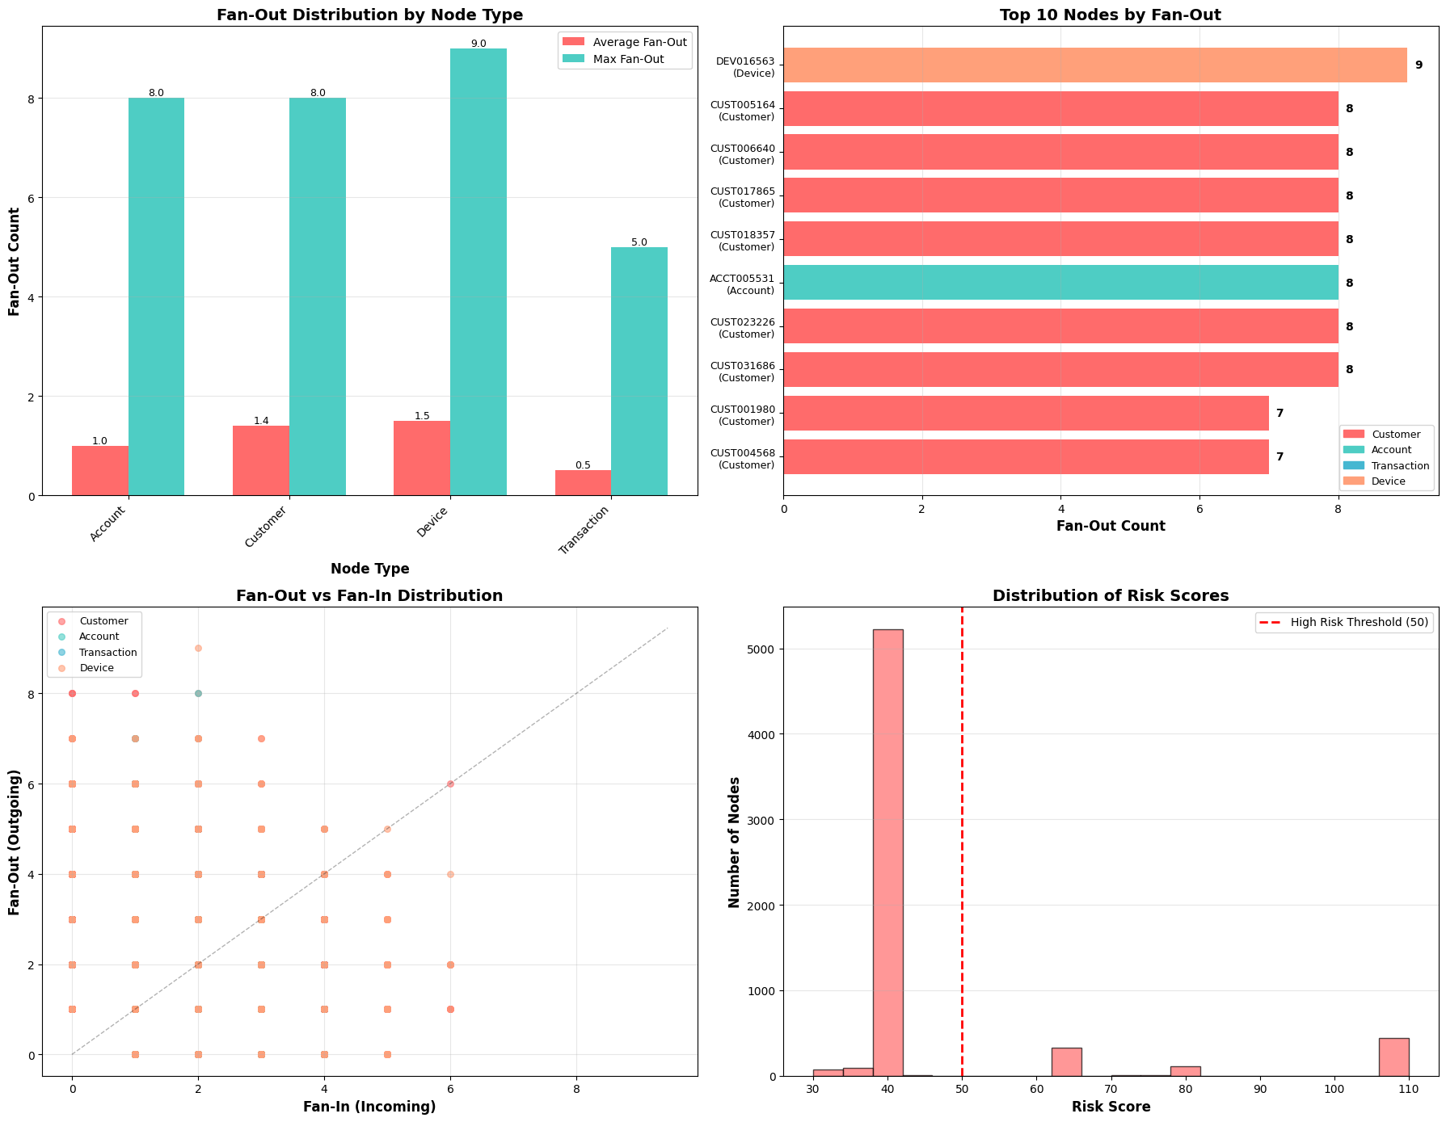
Visualization generated!

====================================================================================================
✅ FAN-OUT DETECTION ANALYSIS COMPLETE
====================================================================================================

